What is the difference between dependency injection and inversion control

In IOC the control flow is delegated to callback delegates, observer pattern, events, DI (Dependency injection) and lot of other ways.
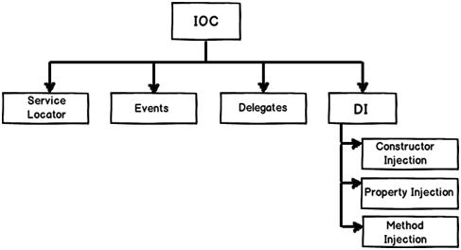
IOC (Inversion of control) is a general parent term, while DI (Dependency injection) is a subset of IOC. IOC is a concept where the flow of application is inverted.

Ex of Event Based IOC
Without IOC
- InputStream process the message on Socket.
- Stream is blocked till it processes all the messages.
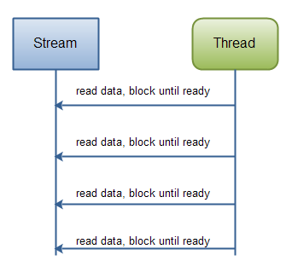
With IOC (Here control flow is inversed by object notification events.)
- Use NIO to process the message on Socket
- Buffer will collect the data. If the dataBuffer is full send an object notification to read data from buffer.
With IOC ( JMS Queue. Here control flow is inversed by JMS message event)
- Use JMS onMessage() method to get message from queue instead of JMS receive() method

What is Dependency Injection
DI provides objects that an object needs. So the dependencies for an object is not constructed by themselves they are injected by some external means.
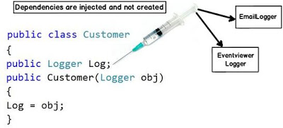
The biggest benefit achieved by the above approach is “Decoupling”. You can now invoke the customer object and pass any kind of “Logger” object as shown in the below code.
Customer obj = new Customer(new EmailLogger());
Customer obj1 = new Customer(new EventViewerLogger());

